**Project**

Characterization of the cerebral visual physiology of healthy subjects and patients with neuro-ophthalmological disorders secondary to stroke and traumatic brain injury using portable and low-cost electroencephalography

Daniela Alejandra Ortega Rosero

BSc Bioengineer

Master's project

Research group in bioinstrumentation and clinical engineering (GIBIC)

Universidad de Antioquia

dalejandra.ortega@udea.edu.co - danni9310@gmail.com

**Advisors**

John Fredy Ochoa Juan Camilo Suárez

Ph.D. in electronic engineering Ph.D. candidate in medical sciences

[john.ochoa@udea.edu.co](mailto:john.ochoa@udea.edu.co) [juanca.suarez@upb.edu.co](mailto:juanca.suarez@upb.edu.co)

Engineering - Neurological rehabilitation - Vision disorders - Electroencephalography

**Acknowledgements**

**Contents**

**List of tables** 5

**List of figures** 6

**1.** **Abstract** 7

**2.** **Introduction** 8

**2.1 Motivation** 8

**2.2** **Objectives** 9

**2.3** **Thesis outline** 10

**3.** **Neurophysiological foundations** 11

**3.1** **Visual system map** 11

**3.2** **Visual functions** 12

3.2.1 Acuity 12

3.2.2 Contrast sensitivity 13

3.2.3 Visual field 13

3.2.4 Motion perception 14

3.2.5 Form recognition 15

3.2.6 Read words 16

3.2.7 Color detection 16

3.2.8 Image description 17

**3.3 Therapy and neuroplasticity** 17

**4.** **Visual electrophysiology** 19

**4.1** **Electroencephalography (EEG)** 19

**4.2 Quantitative electroencephalography (qEEG)** 21

4.2.1 Steady-state visual evoked potentials (SSVEPs) 21

4.2.2 Power Spectrum Estimation 24

4.2.3 Synchronization likelihood (SL) 25

4.2.4 Active information storage (AIS) 27

**5.** **Data processing** 27

**5.1** **Reduction of dimensionality** 27

**5.2** **Repeated measure** 27

**5.3** **Classification algorithms** 27

**6.** **Methodology** 28

**6.1** **Subjects** 28

**6.2** **Experimental setup** 28

**6.3** **EEG acquisition** 29

**6.4** **EEG processing and data analysis** 30

**6.5** **Ethics statement** 32

**7.** **Results and discussion** 33

**7.1** **Set of test** 33

**7.2** **Study in healthy control individuals** 37

**7.3** **Study in patients with neuro-ophthalmological disorders** 43

**7.4** **Classification** 43

**8.** **Conclusions** 43

**9.** **Bibliography** 43

**10.** **Supplementary material** 49

# **List of tables**

# **List of figures**

# 

Figure 1. Visual field maps are measured in the right hemisphere of a single subject using expanding ring and rotating wedge stimuli. [29] 10

Figure 2. Random-dot kinematograms (RDKs). A fully coherent RDK (a) and two partially coherent RDKs (b and c) are shown. The direction of each dot’s movement, indicated here by an arrow, is separately controlled so that the percentage of dots moving in the same [50] 14

Figure 3. The expected location of LOC based on group data from seven neurologically intact participants [52] 14

Figure 4. Survey of procedures used in neurovisual rehabilitation [74] 18

Figure 5. The SSVEP elicited by the 7-Hz stimulation shows characteristic frequency components with peaks at the fundamental and harmonic frequencies at the O2 electrode [44]. 22

Figure 6. Processing for acuity analysis 23

Figure 7. Stimuli for contrast sensitivity 25

Figure 8. Illustration of the concept of the synchronization likelihood [50]. 26

Figure 9. Conditions for the room 29

Figure 10. Electrode Placement 29

Figure 11. Diagram for data processing 30

# **Abstract**

The ability to see and process images depends on the function of the eyes and a large extent on the processing of neuronal information, for this reason, it is important to study the neuronal activity. Approximately 60% of stroke survivors have visual impairments implying the need for rehabilitation therapy. However, although neuronal information is important, currently, brain activity is not recorded during therapies, so the neuronal changes due to therapy are unknown, only the clinical changes of the patients are known, and only on those cases when exist response to the therapy. A limitation to the study of brains’ activity during therapy is the cost and portability of the instrumentation required. The present study aims to characterize the cerebral physiology of visual system with measures such as power spectrum, synchronization likelihood and active information, acquired through portable and low cost electroencephalography (EEG) in healthy subjects and patients with neuro-ophthalmological disorders secondary to stroke and traumatic brain injury in order to have biomarker that allow in future studies to follow up the patients’ process in therapy.

**Keywords:**

# **Introduction**

This chapter is divided in three sections: motivation, objectives for the proposed work and the thesis outline.

## **2.1 Motivation**

The ability to see and process images depend on the function of the eyes and also to a large extent on the processing of neuronal information, for this reason, it is important to study the neuronal activity. Loss of vision may be the consequence of damage of the eye, the retina or consequence of brain damage due to stroke or trauma which affects the visual system [1], [2]. Between 30% and 85% of patients will experience some type of visual dysfunction following a stroke [3], [4]. The visual deficits most frequent in patients with stroke are visual field loss, hemianopsia and diplopia [5]. More than half a million patients are treated annually for head injuries, 90.000 of whom require extended inpatient rehabilitation services [6]. In moderate to severe traumatic brain injury (TBI), it is reported that about 74% of patients have visual alterations, and 38% are visually impaired [7], [8]. Stroke is one of the first causes of disability-adjusted life year (DALYs) [9].

Although the problems with vision loss due to damage of the central nervous system (CNS) have been assumed as irreversible, over the past two decades, neuropsychological research has shown that the “blind” regions of the visual field have a hitherto little-recognized ability to process residual vision. In the last years, new efforts have been made to “reactivate” such residual visual potential through vision training methods [1] [10]. The broad aim of rehabilitation is to achieve the best functional outcome for the patient. Within the rehabilitation team, the occupational therapist aims to improve or maintain independent function in all aspects of daily living including physical, cognitive and social behavior [6] [7].

For these reasons, successful management of these lesions depends on accurate diagnostic, prognostic assessment, and a careful rehabilitation process. The use of positron emission tomography (PET) and functional magnetic resonance imaging (fMRI) following stroke or trauma are important as measures of cerebral physiology [12] [13]. These are imaging tools that clinicians still rely on for the very first stage of diagnosis after TBI and stroke. fMRI and PET are useful in the first stage of diagnosis and establishing the extent of damage with the highest spatial resolution. Functional neuroimaging methods have been developed and new structural neuroimaging techniques also have been added to the toolbox of rehabilitation researchers because these techniques offer the ability to assess human white matter pathways in vivo and have a highest spatial resolution [14]. These are imaging techniques that clinicians use on for the very first stage of diagnosis after TBI and stroke. fMRI and PET are useful in the first stage of diagnosis and establishing the extent of the damage.

However, for therapy follow-up, PET is not often used due to its use of radioactive materials is invasive, and is extremely expensive. fMRI is a technique that produces images at a higher resolution than PET and does not require radioactive materials, although is also very expensive and not portable. In contrast, the EEG is inexpensive with highest temporal resolution and useful technology to measure of cerebral neurophysiology [6] [15].

In this line, quantitative EEG (qEEG) has proven to be useful in the diagnosis and rehabilitation [16] of cognitive problems of TBI individual [17] and visual evoked potentials (VEPs) have shown information on the functional status of the visual system [18]. Other studies have used these potentials to characterize vision functions in children and adults and to have objective measures that support clinical evaluations in healthy subjects and in patients with visual impairment [19] [20] [21] [22] [23] [24]. However, although VEPs are measurements that offer important information of amplitude, latency, spectral characteristics, some of them are sensitive to external factors such as the monitor type [25], signal acquisition system, room light, etc. For this reason, it is important to analyze new EEG measures that can be sensitive indicators of pathologies [26] and use portable equipment that facilitates the implementation in clinical environments.

The present study aims to characterize EEG signals of the visual system in healthy subjects and patients with neuro-ophthalmological disorders secondary to stroke and TBI, in order to have new parameters or biomarkers that allow in future studies to follow up patients in therapy. This study will allow the design and tests of a complete stimulation protocol that takes into account the visual tests used clinically and qEEG values such as VEPs, power spectrum, synchronization likelihood, and active information. The signal will be measured with a portable system to facilitate that the system can be used in rehabilitation clinics.

This project seeks to answer the following research question:

1. ¿What are the qEEG parameters and values that allow to characterize the visual system and differentiate between healthy people and patients with neuro-ophthalmological disorders secondary to stroke and traumatic brain injury?
   1. **Objectives**

General objective

Characterize of the cerebral visual physiology of healthy subjects and patients with neuro-ophthalmological disorders secondary to stroke and traumatic brain injury using portable and low-cost electroencephalography.

Specific objectives

1. To design and build a set of test to evaluate vision during EEG recordings.
2. To measure neuronal activation using EEG in healthy control individuals during visual stimulation to obtain the baseline of clinical measures and qEEG values.
3. To measure neuronal activation using EEG in patients with neuro-ophthalmological disorders secondary to stroke and TBI during visual stimulation to obtain clinical measures and qEEG values.
4. To evaluate the capacity of the qEEG measures obtained to classify healthy subjects from subjects with a disorder of vision.

## **Thesis outline**

For a better understanding of the theme, this work is divided in five chapters. The Chapter 3 is about the neurophysiological foundations to understanding the brain activity. In Chapter 4, information about visual electrophysiology. The data processing methods are shown in Chapter 5. In Chapter 6 we covered the experimental results. Finally, in Chapter 7, the main conclusion of this work are presented, as well as some proposed future works.

# **Neurophysiological foundations**

## **Visual system map**

The search for organizing principles of visual processing in cortex has proven long and fruitful, demonstrating specific types of organization arising on multiple scales. One of the more important larger scale organizing principles of visual cortical organization is the visual field map (VFM) that have allowed to form one complete representation of contralateral visual space. [27]

The visual system has been subdivided into many functional areas. These areas have been found with post-mortem material based on the heavy myelination or with fMRI [28]. The study of visual cortex has revealed three human hemifield maps near the calcarine sulcus in the occipital lobe (Figure 1). Primary visual cortex (V1), which receives direct input from the retinogeniculate pathway, occupies calcarine cortex and represents a hemifield of visual space. Two additional maps (V2, V3) occupy a strip of cortex, roughly 1–3 cm wide, which encircles V1 [29] . This map allows to focus the visual function in the occipital area, for this reason, the study in visual impairment is made in this zone.

Figure 1. Visual field maps are measured in the right hemisphere of a single subject using expanding ring and rotating wedge stimuli. [29]

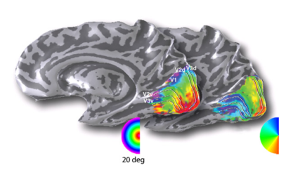

Multiple extrastriate visual areas, each specialized for the detection of particular attributes of visual scenes, are organized into two roughly parallel processing streams (Figure 2). The ventral stream mediates visual recognition of objects (the “what” pathway) and the dorsal stream is specialized for processing spatial relationships among objects (the “where” pathway). Lesions of inferior temporal cortex caused severe deficits of visual discrimination (identifying objects, color, patterns, or shapes) without affecting visuospatial performance (visually guided reaching or judging the distance between objects); conversely, lesions of posterior parietal cortex had the opposite effects. [30]

The complexity of receptive field properties progressively increases from lower-order to higher-order processing areas. Information is integrated to endow higher-order neurons with receptive fields of greatly increased size and complexity.

Figure 2. Schematic of the dorsal and ventral processing streams. MST, medial superior temporal area; LO, lateral occipital; FFA, fusiform face area; PPA, parahippocampal place area. [30]

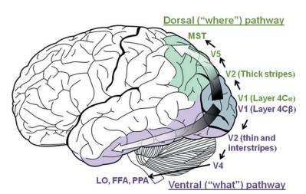

## **Visual functions**

There are different visual functions that are evaluated for the ophthalmologists, in clinical applications they try to verify the functions that have an important role in daily life. Among these functions are: acuity, contrast sensitivity, visual field, motion perception, form recognition, read words, color detection, and image description. These function and the distribution areas will be explaining in this chapter.

### 3.2.1 Acuity

Visual acuity (VA) is a measure of the ability of the eye to distinguish shapes and the details of objects at a given distance. It is important to assess VA in a consistent way in order to detect any changes in vision. In acuity studies, one eye is tested at a time [31] [32].

There are many causes of decreased visual acuity in stroke patients, TBI patients and the general population, including refractive error, glaucoma, cataract, and others. Some causes are more readily treatable than others, but if poor visual acuity is not even highlighted in a patient, then easily correctable causes may go untreated and the rehabilitation and subsequent quality of life may be adversely affected [33][4].

Acuity thresholds can be determined either by psychophysical techniques such as Teller acuity cards [32], Snellen chart [34], Bailey-Lovie and ETDRS chart or by electrophysiological procedures [35][36][37][38]. This last measure will be explaining in the section 4.2.1.1.

Poor visual acuity is a risk factor for falls and a common impediment to rehabilitation, and after stroke, visual impairment may exacerbate the impact of other impairments on overall disability. Postural stability has been shown to be related to visual conditions, and visual ability has been shown to contribute to both the level of care needed and the patient’s level of satisfaction with life following stroke [33].

### 3.2.2 Contrast sensitivity

Contrast sensitivity is the measure of the ability of an individual to detect a difference in the luminance between 2 areas. It is important in detecting objects without clear outlines and discriminating objects or details from their background [39] [40].

This ability is diminished following stroke. Patients complain of not being able to tell the curb from the road or read the newspaper because the print closely resembles the background [4]. Contrast sensitivity can be measured using the Pelli-Robson Chart (Light- house International) [41][39] or by electrophysiological procedures [22][21] (it will be explaining in the section 4.2.1.2.)

### 3.2.3 Visual field

The visual field is how wide of an area the eye can see when you focus on a central point. Visual field testing is one way ophthalmologist measures how much vision have in either eye, and how much vision loss may have occurred over time [42]. Some tests for evaluating this function are: high resolution perimetry (HRP), Tubingen Automatic Perimeter (TAP), Scanning Laser Ophthalmoscope (SLO) [43] [44]. The Humphrey Visual Field Analyzer is often the instrument of choice for subjects with peripheral field loss or hemianopia. In the case of central field loss, the Humphrey 10-2 test, which focuses on the central 10º of the visual field, may be used [13].

Visual field loss has many causes but is a well-recognised complication of stroke, with an incidence in acute stroke patients reported as 20%. A large study of people in the community showed homonymous visual field defects in 8.3% of post-stroke patients. A smaller study showed asymptomatic visual field loss in 29% of transient ischaemic attack (TIA) patients and 57% of minor stroke patients, which, though asymptomatic, may carry implications for tasks such as driving [33] [4].

Visual field loss is associated with impairment in daily functioning and a higher risk of incident falling, which obviously has implications for rehabilitation. It is also an important predictor of functional status on discharge from stroke rehabilitation units. Some studies have shown that vision restoration therapy (VRT) or computer-based training program improve significantly the visual fields [45][43]. A German study of 21 hemianopic patients and 23 controls showed that 4 weeks of compensatory visual field training led to a marked improvement in detection and reaction time of visual stimuli in all their subjects with hemianopia and that this improvement was still maintained at 8 months [33].

### 3.2.4 Motion perception

Motion information is required for the solution of many complex tasks of the visual system such as depth perception by motion parallax and figure/ground discrimination by relative motion [46]. Brain imaging studies report an increase in activation in and around area V5 when subjects are presented with moving checkerboards, form from-motion displays coherent or incoherent motion displays and even illusory motion [47] [48] [49].

Neurological patients whose cortical damage includes area V5 have deficits in perceiving motion which range from an almost total inability to perceive the movement of objects to deficits in second-order motion only [48].

Computer-generated random-dot kinematograms (RDKs) can be used to study these motion-selective brain regions. RDKs are made up of two populations of moving dots; a “signal” and a “noise” population. Signal dots move in a common direction, whereas noise dots move randomly (Figure 3). Each dot is assigned a particular motion vector. The observer’s task is to indicate the direction of the signal dots. Theoretically, cells in V1 provide information relating to the motion of individual dots, whereas cells within V5/MT are able to integrate information from V1 to resolve the global motion of the stimulus [49][47][50][51].

Figure 3. Random-dot kinematograms (RDKs). A fully coherent RDK (a) and two partially coherent RDKs (b and c) are shown. The direction of each dot’s movement, indicated here by an arrow, is separately controlled so that the percentage of dots moving in the same. [51]

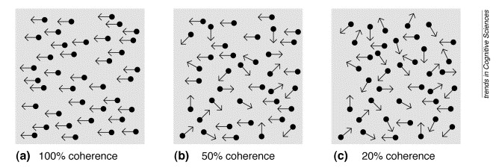

### 3.2.5 Form recognition

Another of the extraordinary capabilities of the human visual system is its ability to rapidly group elements in a complex visual scene, a process that can greatly simplify the description of an image. For example, a collection of parallel lines can be described as a single texture pattern without specifying the location, length, and orientation of each element within the pattern. Such grouping processes are reflected in the activities of neurons at various stages of the visual system. Recent neuroimaging studies (Figure 4) have shown that the lateral occipital complex (LOC) is a higher visual area critical for object shape perception [52]

Figure 4. The expected location of LOC based on group data from seven neurologically intact participants. [53]

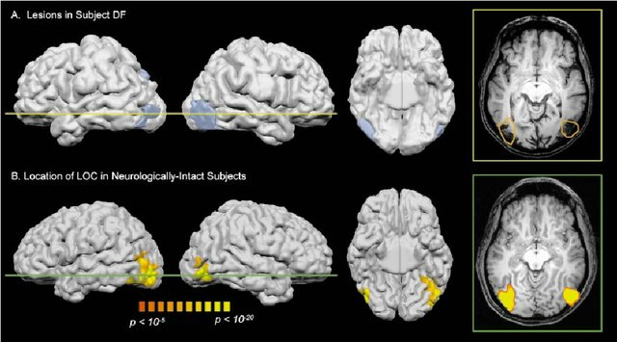

The overall shape of an object is an important cue for object recognition, as many objects are perfectly recognizable from the shape cues alone, e.g., in the case of silhouettes and line drawings. In general, shape integration in humans seems to be fast and largely invariant to such low-level physical properties of stimuli as contrast or gross size [54] .

Patients with visual [agnosia](https://www.sciencedirect.com/topics/neuroscience/agnosia) have difficulties with recognizing objects because of impairments in basic perceptual processing or higher-level recognition processes. Such patients can still recognize objects by using other senses such as touch, hearing, or smell, so the loss of function is strictly visual. The word *agnosia* can be translated from Greek as meaning “to lack knowledge of,” so visual agnosia implies a loss of visual knowledge [55] [56].

Visual agnosia is diagnosed by assessing the patient's ability to name, describe uses for, and pantomime the use of visually presented objects. Extensive occipital damage due to anoxic insult or severe infarction is the usual cause of this rare syndrome [57] .

In addition to this, previous studies have shown that this grouping process modulates neural activity in the primary visual cortex (V1) that is signaling the local elements. However, the nature of this modulation is controversial. Some studies find that shape perception reduces neural activity in V1, while others report increased V1 activity during shape perception [58].

### 3.2.6 Read words

During the following decades, advances in neuroimaging measurements provided compelling evidence that regions within ventral occipital-temporal (VOT) cortex are part of the network for skilled reading [59][60]. VOT responses are relatively weak in poor readers, in healthy skilled readers, VOT circuitry is highly responsive to visual word forms, during development, improvements in reading performance are correlated with increases in VOT responses to written words [59].

The first steps in the process of reading a printed word belong to the domain of visual object perception. They culminate in a representation of letter strings as an ordered set of abstract letter identities, a representation known as the Visual Word Form (VWF) [60][61]. Brain lesions in patients with pure alexia and functional imaging data suggest that the VWF is subtended by a restricted patch of left‐hemispheric fusiform cortex, which is reproducibly activated during reading [62] [63].

### 3.2.7 Color detection

Color vision, the ability to discriminate variations in the wavelength of light independent of intensity, involves multiple stages of processing. Each region of the retina has cone photoreceptors containing photopigments of different spectral sensitivities [64].

Color is primarily processed in the blobs of V1, in the thin stripes of V2, in the human V4 complex, and in regions anterior to it. Although information on both features is present in V1, V2, and V4, it appears to be largely segregated at the cellular level. There is seemingly no evidence for chromatically selective neurons in V5/MT+, although the area does have reciprocal connections with V4 and some of its neurons can respond to moving isoluminant edges [65]

Achromatopsia is a syndrome in which after cortical damage to specific part of the human brain namely the color centre in the fusiform gyrus, the patient is unable to see the world in color but only ‘dirty’ shades of grey [66][67]. The physiological evidence for this segregation is confirmed in a causal way by patient studies, showing that lesions in the vicinity of V4 impair color perception.

Achromatopsia can result from cortical damage and are most commonly associated with stroke. Such cases have the potential to provide useful information regarding the loci of the generation of the percept of color [68].

In one study, three types of visual stimulus were presented to the subjects during an experimental session. The first stimulus was a chromatic Mondrian pattern which comprised eight differently colored elements, assembled in such a way as to provide an abstract scene with no recognizable objects. The colored Mondrian pattern was alternated at a rate of 1 Hz with a blank background of the same mean luminance and mean hue. Prior to scanning the subjects set isoluminance for each of the colors in the stimulus by the technique of heterochromatic flicker photometry [69]

### 3.2.8 Image description

Human extrastriate cortex contains a number of regions that respond selectively to specific categories of visual stimuli: the fusiform face area (FFA), which responds selectively to face; the parahippocampal place area, which responds selectively to scenes; and the extrastriate body area and fusiform body area, which respond selectively to human bodies and body parts. Each of these regions can be found in roughly the same anatomical location in most subjects [70].

To describe an image, it is necessary that all the functions explained above work properly. This is the most complex function of the visual system and it requires of all occipital region.

## **3.3 Therapy and neuroplasticity**

Vision loss is one of the more debilitating sensory deficit for humans given that we rely heavily on our sense of sight in gathering information from the external environment. This becomes more evident when is considered the percentage of cerebral cortex allocated to our visual system, which imposes a high risk for visual loss whenever brain damage occurs. There is a 20 to 30% chance of losing some amount of visual capacity leading to visual field disorder (VFD) after a stroke or brain trauma [1] [71] [72].

Rehabilitation training programs are based on the theory that neuroplasticity reorganizes the damaged cerebral cortex, and it focuses on recovery of the damaged cognitive function and the minimization of the effects of the damage [73]. Neuroplasticity is an intrinsic property of the central nervous system that is also present during adult life and allows remodeling of specific brain networks in an attempt to optimize cortical function in response to learning and injury [74]. When this plasticity genuinely aids clinical recovery or maintains clinical function in the presence of persistent structural damage, it is known as compensatory plasticity [75].

Contrast sensitivity, visual acuity, and visual field are the most common outcome measures to evaluate functional changes due to a therapy [71], [41] [33]. Some techniques as VRT have reported subjective improvements in activities of daily life (ADL). For example, they felt more comfortable walking on the street because they felt safer after VRT than before. Also, they were able to read the newspaper again. Interestingly, some patients with no evidence of improved visual field size (according to diagnostic testing), still reported subjective improvements in ADL. These results suggest that besides training induced visual field changes other factors may play an important role in subjective ADL improvements after VRT [76]

Neurovisual rehabilitation is still offered less frequent that motor and speech therapy. However, there is an increasing awareness of the need for it. Neurovisual rehabilitation focuses on three major strategies: restitution, compensation, and/ or substitution.

Restitution, it focuses on the utilization of the areas described as ‘areas of residual vision’. This implies that there are sectors of the visual field that do not function normally, but where some of the visual brain capacities have survived the ischemic injury. Most often treatments for neurovisual disorders try to utilise intact functions (compensation), use or try to develop optic and prosthethic devices, or aim at improving the adaptation of the environment to the patient's impairment (substitution). Nevertheless, there are approaches for direct retraining of an impaired function (restitution)—that is, perimetric visual field training or the training of convergent fusion (Figure 5). [77]

Figure 5. Survey of procedures used in neurovisual rehabilitation [77]

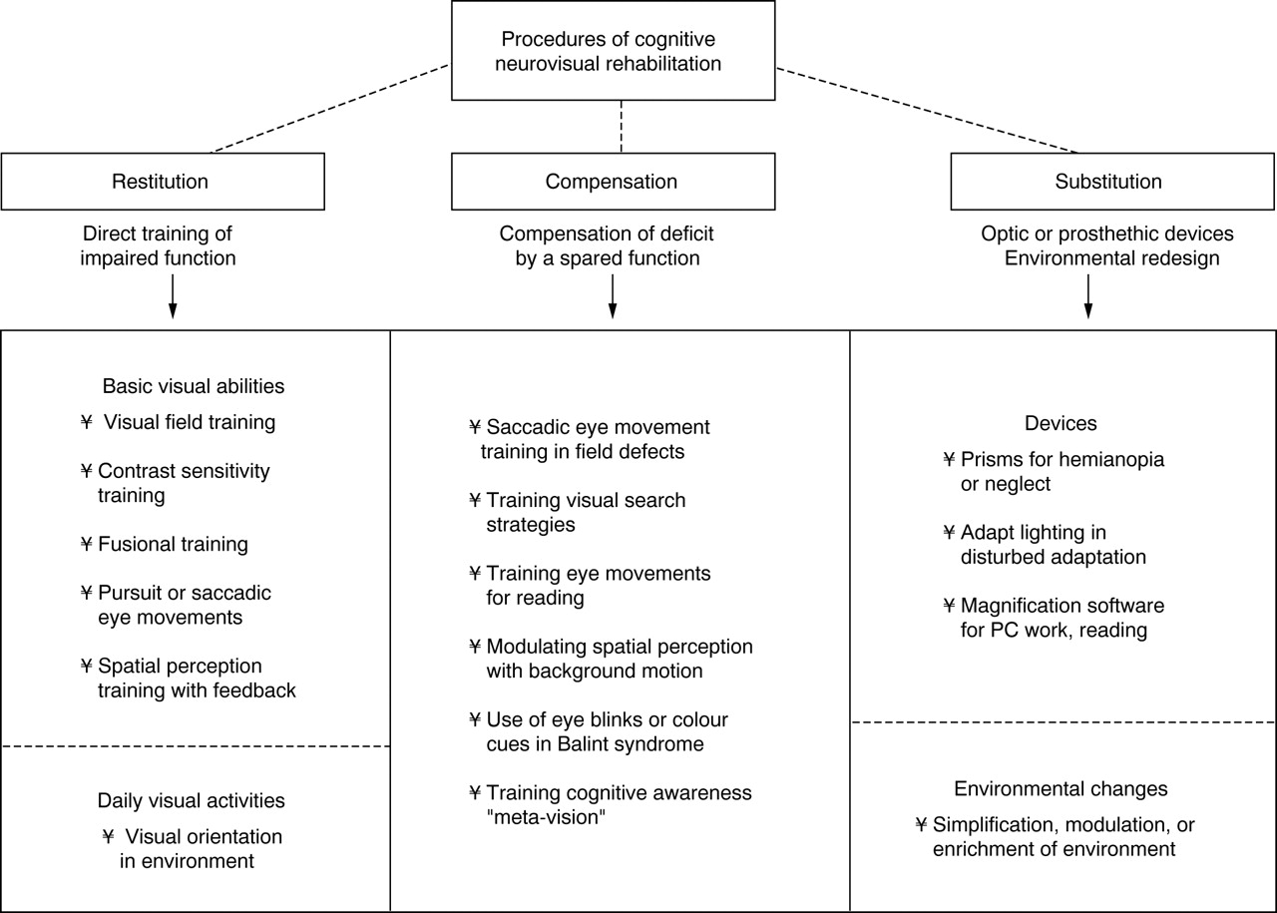

Enfermedades

Eyes and stroke: the visual aspects of cerebrovascular disease

A large portion of the central nervous system is dedicated to vision and therefore strokes have a high likelihood of involving vision in some way. Vision loss can be the most disabling residual effect after a cerebral infarction. Transient vision problems can likewise be a harbinger of stroke and prompt evaluation after recognition of visual symptoms can prevent future vascular injury. In this review, we discuss the visual aspects of stroke. First, anatomy and the vascular supply of the visual system are considered. Then, the different stroke syndromes which involve vision are discussed. Finally, topics involving the assessment, prognosis, treatment and therapeutic intervention of visionspecific stroke topics are reviewed [78]

1. **Visual electrophysiology**

## **Electroencephalography (EEG)**

EEG signals are easily recorded in a non-invasive manner through electrodes placed over the scalp and have a high temporal resolution, being that the reasons why it is the most widespread recording modality. EEG measures electric brain activity caused by the flow of electric currents during synaptic excitations of the dendrites in the neurons. [79] [80]. This technique is portable, economical and with high temporal resolution and offering the possibility to monitor the fast dynamic changes in brain activity [81].

The recorded EEG signal is a monitoring method to record electrical activity over time. This method contains frequency components that can be measured and analyzed [79] [82]. Time-frequency analysis of the EEG electrical activity in time can be performed using Fourier decomposition and the frequency components have been described mainly in the bands delta (δ), theta (θ), alpha (α), beta (β), and gamma (γ) from low to high, respectively, which have been defined due to their characteristic presence depending on brain states. Table 1 shows the commonly defined waves or rhythms, their frequency, and their properties.

Table 1. Properties for each frequency band [79] [82].

|  |  |  |
| --- | --- | --- |
| **Rhythms name** | **Frequency band (Hz)** | **Properties** |
| **Delta** | <4 | The amplitude of delta signals detected in babies decreases as they age. Delta rhythms are usually only observed in adults in deep sleep state and are unusual in adults in an awake state. A large amount of delta activity in awake adults is abnormal and is related to neurological diseases. |
| **Theta** | 4-7 | In a normal awake adult, only a small amount of theta frequencies can be recorded. A larger amount of theta frequencies can be seen in young children, older children, and adults in drowsy, meditative or sleep states. Like delta waves, a large amount of theta activity in awake adults is related to neurological disease. Theta band has been associated with meditative concentration and a wide range of cognitive processes such as mental calculation, maze task demands, or conscious awareness. |
| **Alpha** | 8-12 | Their amplitude increases when the eyes close and the body relaxes and they attenuate when the eyes open and mental effort is made. These rhythms primarily reflect visual processing in the occipital brain region and may also be related to the memory brain function. There is also evidence that alpha activity may be associated with the mental effort. Attention tasks cause a suppression of alpha activity, particularly from the frontal areas. Consequently, these rhythms might be useful signals to measure mental effort. |
| **Beta** | 12-30 | Rhythms beta are recorded in the frontal and central regions of the brain and are associated with motor activities. Beta rhythms are desynchronized during real movement or motor imagery. Beta waves are characterized by their symmetrical distribution when there is no motor activity. However, in the case of active movement, beta waves attenuate, and their symmetrical distribution changes. |
| **Gamma** | >30 | The presence of gamma waves in the brain activity of a healthy adult is related to certain motor functions or perceptions. This gamma band coherence is replaced by a beta band coherence during weak contractions, suggesting a correlation between gamma or beta cortical oscillatory activity and force. Also, several studies have provided evidence for the role of gamma activity in the perception of both visual and auditory stimuli. Gamma rhythms are less commonly used in EEG-based BCI systems because artifacts such as electromyography (EMG) or electrooculography (EOG) are likely to affect them. |

## **4.2 Quantitative electroencephalography (qEEG)**

qEEG as the name implies, is a means of electrically processing the EEG signal to quantify the relative contributions of each frequency or other characteristics in the signal. qEEG represents a family of related technologies and techniques, however, the common foundation upon which they all are built is spectral analysis. Spectral analysis is a process by which a given segment of the complex EEG signal is separated into its component frequencies. Spectral analysis of the EEG signal reveals the amount of alpha, beta, delta, and theta activity contained in the signal [6]. This allows for comparison over time of changes in the composition of the EEG signal. A new area of research focusing on the changes in qEEG measures as a result of rehabilitation attempts has begun to appear, with interesting results [17]. Leon-Carrion et al. [83] reported on the relation between recovery at 6 months and delta–alpha ratios (eyes closed data). A higher delta–alpha initial value was associated with poorer recovery.

### 4.2.1 Steady-state visual evoked potentials (SSVEPs)

Other studies have decided to use steady-state VEPs (SSVEP) to analyze neuro-ophthalmologic diseases [18]. The SSVEP is a robust method to study visual perception, spatial and selective attention, cognitive fatigue, and working memory [84]. Repetitive (or flickering) visual stimuli are presented at a high rate (usually from 6 to 20 Hz) [85], eliciting a continuous and steady sequence of oscillatory potential changes arising mainly in the visual cortex. This stimulation is rapid enough to prevent the evoked neural activity from returning to baseline. The SSVEPs reflect high propagation properties (i.e. a combination of locally and widely temporally distributed sources), are less sensitive to different kinds of artifacts, require much less time to acquire data and have a larger signal-to-noise ratio (SNR) than transient VEPs [18] [86] [87]. An example of the SSVEPs seen using the Fast Fourier Transform is shown in Figure 6.

Figure 6. The SSVEP elicited by the 7-Hz stimulation shows characteristic frequency components with peaks at the fundamental and harmonic frequencies at the O2 electrode [44].



SSVEPs have allowed measuring acuity [88] and contrast sensitivity [37] and it is important to find an objective measure.

* + - 1. Acuity measure

The assessment of vision is an essential part of any ophthalmological or optometric examination with visual acuity being the most commonly measured visual function. Contrast sensitivity is another important visual function that has been studied extensively in terms of its development in infants. A subjective assessment is usually done for verbal and cooperative individuals by using visual acuity and contrast sensitivity charts [22].

Different techniques have been used to find acuity, Vernier acuity is one of them. This technique is a measure of the eyes ability to perceive that a misalignment exists between the elements of the stimulus, when compared with a stimulus without such misalignment. By sweeping spatial frequency from low to high in about 10 s, an estimation of visual acuity is obtained by determining the highest spatial frequency to which the visual system responds [22] [38] . Figure 7 shows the how is possible to get the acuity measure with analysis in power spectrum.

Figure 7. (A, left) Original traces and spectra for each special frequency. To the right of the traces are the corresponding Fourier spectra (1–100 Hz), showing a clear line at 7.5 Hz for all but the smallest check size – 7.5Hz is the stimuli frequency. (B, below) Tuning curve. The noise-corrected response magnitude at 7.5 Hz is plotted versus the logarithm of the dominant spatial frequency of the checkerboard stimulus. The circle at the highest spatial frequency indicates a non-significant response. The thick regression line was based on the ‘‘stepwise heuristic algorithm’’. In this example, the extrapolation to zero amplitude yields a spatial frequency (SF0) of 10 cpd=14.1 cpd. [38]

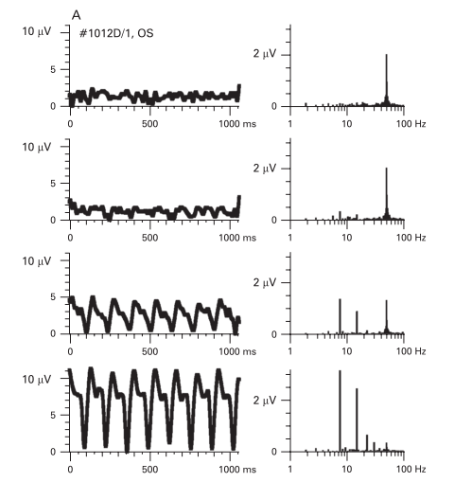

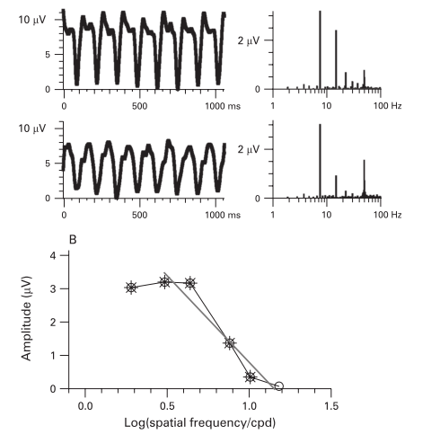

* + - 1. Contrast measure

Measurements of spatial frequency threshold (grating acuity) and contrast sensitivity using the sVEP have been obtained previously in full-term, healthy infants and adults. [21]. Figure 8 is a schema of the typical stimuli for contrast measure. In this case, the contrast sweep stimulus was a 1 c/deg black vertical cosine-wave grating presented on a 109 cd/m2 space-average luminance white background screen in a pattern on/off mode at a rate of 3.76 Hz.

Figure 8. Stimuli for contrast sensitivity [21]

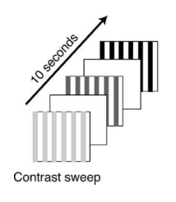

Using the same processing than in Vernier acuity it possible to get the contrast value. Figure 9 shows a graph for contrast measure, threshold was determined by extrapolation of a regression line from the signal peak to zero microvolt amplitude against percentage contrast for contrast threshold measurement [89].

Figure 9. Example showing contrast plot [89].

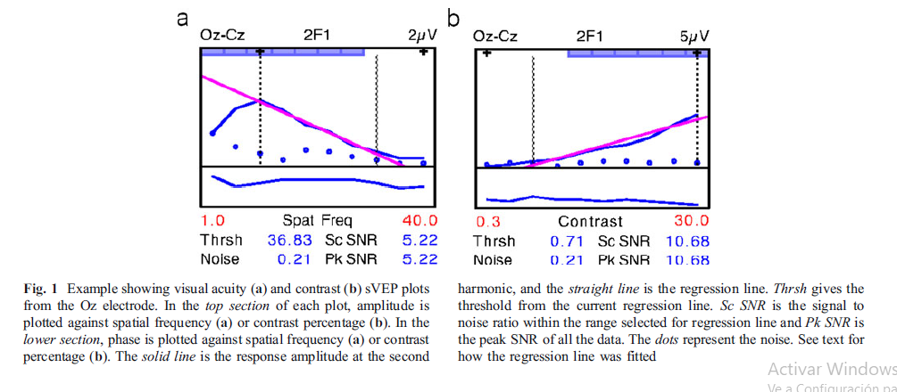

### 4.2.2 Power Spectrum Estimation

The power spectrum or the power spectral density (PSD) of an EEG raw signal in function of time is defined as the Fourier transform of the autocorrelation function . It is defined as follows:

Where:

However, it can be shown that the PSD is equivalent to that obtained using the discrete time Fourier transform (DFT) in:

Where

The PSD estimation using the DFT is known as the periodogram, which can easily be calculated using the fast Fourier transform (FFT) method. If we increase N, the mean value of the periodogram will converge to the true PSD, but unfortunately, the variance does not decrease to zero. Therefore, the periodogram is a biased estimator. To reduce the variance of the periodogram, ensemble averaging is used. The resultant power spectrum is called the average periodogram. One of the most popular methods for computing the average periodogram is the Welch method, in which windowed overlapping segments are used [90].

Some studies have researched the power spectrum in rehabilitation therapy. Stathopoulou and Lubar [91] reported that the most systemic change on the EEG data (eyes closed, eyes open conditions) in the TBI patients following 22 sessions of a cognitive rehabilitation program was a decrease in alpha, contrary to the expectation of decreased delta, theta, and alpha (microvolts and relative power) and increases in beta. Vespa et al. [92] examined the daily percent alpha variability (PAV) variable on continuous EEG monitoring with moderate to severe TBI 0–10 days after injury. The lower the alpha variability, the poorer was the clinical outcome.

### 4.2.3 Synchronization likelihood (SL)

Assume we have two-time series and . With the method of time-delay embedding, the vectors and are reconstructed in state space. These vectors can be thought of as representing the state of the system underlying the time series at a moment in time. Synchronization likelihood is now defined as the conditional likelihood that and will be very close together, given that and are very close together. In other words, the synchronization likelihood is the likelihood that if system is in the same state at two different times, system will also be in the same state at these two times.

Figure 10. Illustration of the concept of the synchronization likelihood [50].

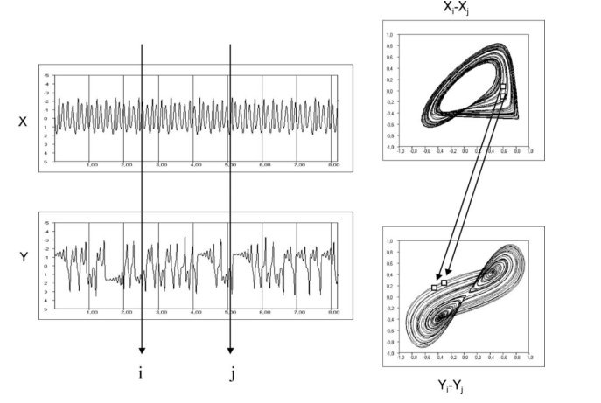

The synchronization likelihood reflects the strength of coupling between two systems. Values of the synchronization likelihood are between a small number close to zero when there is no coupling and one in the case of fully synchronized time series [93].

M is considered simultaneously recorded time series where denotes channel number () and denotes discrete time (). From each of the time series embedded vectors are reconstructed with time-delay embedding:

= (, , , )

where is the lag and is the embedding dimension. For each time series and each time we define the probability that embedded vectors are closer to each other than a distance :

It is defined as follows:

Here the is the Euclidean distance and is the Heaviside step function, if and for . Here and are two windows; is the Theiler correction for autocorrelation effects and should be at least of the order of the autocorrelation time; is a window that sharpens the time resolution of the synchronization measure and is chosen such that . Now for each and each the critical distance determined for which , where . [94].

Molnár, et al. [26] compared spectral and complexity characteristics of the EEG in a unique case of subcortical infarct to those seen in healthy controls. Synchronization likelihood and other measures were calculated of the EEG recorded in eyes closed and eyes open conditions. They concluded that the subcortical infarct caused ipsilaterally increased slow, and decreased fast frequency activity accompanied by decreased synchronization of slow, increased synchronization of fast frequencies.

### 4.2.4 Active information storage (AIS)

The excess entropy measures the total stored information which will be used at some point in the future of the state process of an agent. This information will possibly but not necessarily be used at the next time step . Since the dynamics of computation unfold one step at a time, we are quite interested in how much of the stored information is actually in use at the next time step when the new process value is computed. As such, we derive active information storage as the average mutual information between the semi-infinite past of the process and its next state , as opposed to its whole (semi-infinite) future [95]. represents finite-k estimates:

1. **Data processing**
   1. **Reduction of dimensionality**

Factor Analysis (FA) is an independence technique, in which there is no dependent variable. The motivation of FA relies on the fact that often there are many variables involved in a research design, and it is usually helpful to reduce the variables to a smaller set of factors, aiming mainly to understand the underlying structure of the data matrix. The relationship of each variable to the underlying factor is expressed by the so-called factor loading. Again, in the parametric approach, the independent variables are usually assumed to be normal and continuous, with at least three to five variables loading onto a factor.

<https://www.sciencedirect.com/topics/medicine-and-dentistry/factor-analysis> project was a cross-sectional study

* 1. **Repeated measure**

project was a cross-sectional study

* 1. **Classification algorithms**

project was a cross-sectional study

# **Methodology**

This project was a cross-sectional study with an exploratory and descriptive analysis.

* 1. **Subjects**

This study was made with _____ healthy control subjects and ___ patients with neuro-ophthalmological disorders. Patients were recruited through different ophthalmological clinics in the city of Medellin, Colombia (Ophthalmologic Clinic San Diego and Ophthalmologic Clinic Santa Lucia). Patients were recruited by convenience according to the selection criteria established and it was considered that the sample do not give statistical inference. Healthy control subjects were searched in the University of Antioquia and all measurements was made in a laboratory in the same university. In supplementary material is all information about the participants.

The inclusion criteria and exclusion criteria for the subjects in this research were:

Inclusion criteria healthy subjects:

* Both genders
* Adults (>18 years and <60 years)
* Healthy subjects: no ophthalmologic or neurological disease (acute or chronic). Without epilepsy.

Inclusion criteria patients with neuro-ophthalmological disorders:

* Both genders
* Adults (>18 years and <60 years)
* Visual alteration confirmed by visual acuity or visual fields
* Diagnosis of stroke or TBI, with a time of evolution greater than six months. Without epilepsy.
  1. **Experimental setup**

During the whole experiment, subjects were seated in a comfortable chair in a slightly dimmed room about 1 m in front of the stimulation unit. All subjects completed the test in the same time. Figure 11 show the condition for the room and the basic position for the subjects.

Figure 11. Conditions for the room

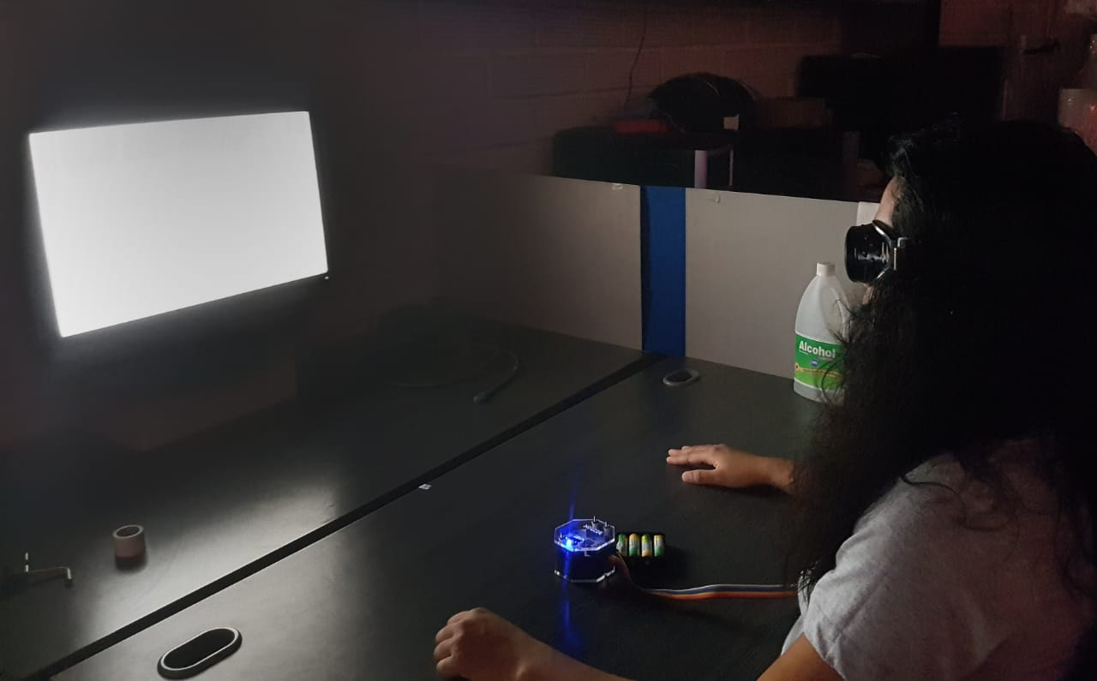

Each subject was in the experiment during 40 minutes. The stimuli were showed for binocular and monocular vision. In each subject 8 test were made. Stimulus was design in python, openDesigner and psychopy and performed in a screen SyncMaster 2243 LNX. Script are open and can be used in other projects (<https://github.com/danni9310/Thesis_stimuli>).

* 1. **EEG acquisition**

An open source BCI headset and data acquisition board OpenBCI were used to acquire EEG signals from the surface of the scalp. The sampling rate was 250 Hz. According to the International 10–10 system, sensors were placed on the scalp at locations FCz, Oz, O1, O2, PO7, PO8, PO3, PO4 (Figure 12). Additionally, two sensors were used on right and left earlobes for reference and ground signals respectively.

Figure 12. Electrode Placement

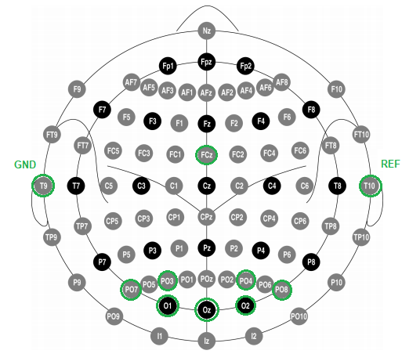

The OpenBCI Cyton Board is an Arduino-compatible, 8-channel neural interface with a 32-bit processor. At its core, the OpenBCI Cyton Board implements the PIC32MX250F128B microcontroller, giving it lots of local memory and fast processing speeds. The board comes pre-flashed with the chipKIT™ bootloader, and the latest OpenBCI firmware [96].

* 1. **EEG processing and data analysis**

The EEG recordings acquired from OpenBCI were processed with Python and statistical analysis was performed by STATGRAPHICS and R. Figure 13 shows the data processing schema.

Figure 13. Diagram for data processing

Repeated measurements design was used to identify the features that allow differentiating the stimuli.

Depending on number of variable, factor analysis was used for dimensionality reduction

An exploratory analysis of the data was carried out to identify atypical data.

Depending of the features, a specific script was developed.

The EEG recordings were band-pass linear filtered at 3-30 Hz.

The signal was divided in monocular and binocular vision (right and lelft).

Feature extraction:

Frequency spectrum were calculated for each bipolar channel by Welch's power spectral density estimate method. This processing was made with a Hamming window.

Relative power spectral in each frequency band was calculated for summation of the values for each band, delta (0-4), theta (4-8), alpha (8-13) and beta (13-30). The result was obtained for each bipolar configuration Oz-FCz, O1-FCz, O2-FCz, PO7-FCz, PO8-FCz, PO3-FCz and PO4-FCZ.

* 1. **Ethics statement**

The study was presented to the Research Ethics Committee at the University of Antioquia and was approved on December 2018. Subjects did not receive any financial reward for participating in this study. Written informed consent was obtained of all participants after explanation of the nature and possible consequences of this study.

In Resolution 8430 of October 4, 1993 (Articles 9 and 11), the definition of risk and the categories that apply to investigations are proposed. The present project was classified as research with minimal risk since it will be a cross-sectional study based on the characterization of signals acquired by non-invasive instruments.

There was not intentional intervention or modification of the behavior or social, medical or work variables of the people (healthy subjects and patients) participating in the study. Medications were not applied and invasive sensors will not be used at the level of the orbital cavity or the eyeball. No new electroencephalography devices will be tested on patients. The sensors used in the project (electrodes of EEG), are evaluated devices and with commercial use in humans so that new devices or in prototype phase will not be used.

# **Results and discussion**

## **Set of test**

In order to evaluate the visual function, the set of test was designed to stimulate vision for different skills. The set contains stimuli to measure: acuity, contrast sensitivity, motion perception, visual field, form detection, reading words, color detection and complex image description. This selection answers to the different skill that are affected when there is a stroke or TBI. Script are open and can be used in other projects (<https://github.com/danni9310/Thesis_stimuli>).

Table 2 explain the characteristics for each test. From resting-state close eyes to visual field stimulus, the participants do not speak, only watch and in some case they have to show with their finger the direction of the points for motion stimulus or if they can watch the square in the monitor for visual field stimulus. From form detection to image description the participants need to say the forms, colors, letters, images they watch.

Stimuli for acuity and contrast measures [20][22][97][98][89][99][100][101][102] have been report in some paper. In some of them, there are experiments to examine whether a higher density of recording electrodes improves the estimation of individual low-level visual thresholds with swept-parameter visual evoked potential (sVEP), [20], others validate intersession and intrasession variabilities of sVEP measurements [97] and some studies use this measure for the detection of amblyopia in adults and children [100][101]. Also, for motion perception [50][51][103][49] and visual field [45] there are some papers with test used in clinical part or in rehabilitation process.

However, there are not a world standard for forms recognition, readings words, color detection and image description stimuli, so in these cases, the stimuli were designed taking into account general clinical information. It was important to use basic forms, common words, main colors and simple images. This part is an exploratory section with basic things in screen.

Table 2. Description for stimuli

|  |  |  |
| --- | --- | --- |
| **Stimuli** | **Diagram** | **Description** |
| Resting-state close eyes | - | 30 seconds with close eyes |
| Resting-state open eyes | - | 30 seconds for binocular and monocular vision with open eyes. |
| Vernier acuity |  | All stimuli alternated between two states at a rate of 3.75 Hz. For the swept paradigm, the size of the displacements of Vernier offset ranged from 2 to 30 cycles per degree (cpd) in a period of 28 s [35][99][100]. The experiment was made for binocular and monocular vision. Stimuli set in openDesigner.  Total time of stimulation for each eye: 28s |
| Contrast sensitivity |  | Contrast sweep 3.75 Hz onset-offset vertical cosine-wave grating with 2 cpd  onset-offset vertical grating space-average luminance white background screen was swept from 0.5% to 100% contrast in linear steps [21]. Stimuli set in openDesigner.  Total time of stimulation for each eye: 28s |
| Motion perception |  | For motion perception, two stimuli were designed. First, stimulus was a square white moving in different direction in the screen with black background. The subjects had to follow the movement of the square and draw in the table with their finger the square direction.  Square size: 60x60 px  Total time of stimulation for each eye: 40s  Second dynamic random-dot kinematograms (RDKs) consisted of a large number of moving dots randomly positioned within a restricted area. Each dot is assigned a particular motion vector. With these stimuli, a variable percentage of dots can be moved in a single coherent (signal) direction whilst remaining dots are moved in random directions (noise) [51][49]. This stimulus was designed in psychoPy3 using 120 dots 0.1 in speed and 22 px for dot size.  Total time of stimulation for each eye: 62s |
| Visual field |  | In visual field stimulus, the patient focuses on a central fixation point in the screen during the entire period of examination, light stimulus was repetitively presented in different parts of the space screen [45]. Only for this stimulus, subject have attended stimulus from 50 cm distance.  White square size: 60x60 px  Total time of stimulation for each eye: 114s |
| Form detection | D:\UDEA-MAESTRIA\Proyecto\Set Stimuli\Scripts in python\Formas\0\1.pngD:\UDEA-MAESTRIA\Proyecto\Codigos estimulos\Formas\0\6.png  D:\UDEA-MAESTRIA\Proyecto\Codigos estimulos\Formas\0\4.png | Form recognition was measured while volunteers were watching universal icons for some objects. Three objects were static and 3 more was showed in D:\UDEA-MAESTRIA\Thesis result\Set Stimuli\Scripts in python\Formas\0\2.pngD:\UDEA-MAESTRIA\Thesis result\Set Stimuli\Scripts in python\Formas\0\7.pngreal size and after it was reduced in scale. Eleven different forms were used: heart, phone, apple, ball, plane, light bulb, clock, scissors, umbrella, house and tooth.  Total time of stimulation for each eye: 50s |
| Reading words | FAMILIA  CASA  ES | Read words stimulus were projected in white font onto a black screen [59][61]. Words with one, two and three syllables were showed while the words were moving right to left or left to right. The words were: LA", "EN", "ES", "UN", "CASA", "LUNA", "ALTO", "HOJA", "ZAPATO", "CUADERNO", "CABEZA" and "FAMILIA".  Total time of stimulation for each eye: 100s |
| Color detection | Resultado de imagen para stroop | Color detection stimulus was designed in three parts. First, basic color (red, blue, green and yellow) was performed in the screen for 5 seconds, after the same color flicker between two different colors in order to change the contrast and finally stroop effect was tested to maintain the concentration in the image.  Total time of stimulation for each eye: 95s |
| Complex image | D:\UDEA-MAESTRIA\Proyecto\Codigos estimulos\Imagenes\1\9.JPGD:\UDEA-MAESTRIA\Proyecto\Codigos estimulos\Imagenes\1\7.jpgD:\UDEA-MAESTRIA\Proyecto\Codigos estimulos\Imagenes\1\4.jpg | Image analysis was designed with 3 types of image. Four images of objects, four faces and four landscapes were shown. Each image was on the screen for five seconds.  Total time of stimulation for each eye: 78s |

## **Study in healthy control individuals**

An exploratory analysis on the EEG recording allowed to clean the database and determine the final signals for analysis by each type of stimulus. In the group 1, 380 test was studied, this dataset has recording for each stimulus and type of vision (binocular - B, monocular left - L and monocular right - R) in the group 2, 337 signal was processed. The datasets are available in a repository on GitHub (<https://github.com/danni9310/Result_Tesis>).

|  |  |  |  |
| --- | --- | --- | --- |
| **Group 1** | | | |
| **Stimuli** | **Binocular** | **Monocular left** | **Monocular right** |
| Vernier acuity | 15 | 16 | 16 |
| Contrast sensitivity | 17 | 17 | 16 |
| Visual field | 13 | 15 | 17 |
| Motio perception (RDKs) | 11 | 13 | 12 |
| Motio perception (Square) | 16 | 17 | 13 |
| Form recognition | 13 | 13 | 13 |
| Read words | 11 | 10 | 11 |
| Color detection | 13 | 14 | 13 |
| Image description | 15 | 14 | 16 |

Relative power in each frequency band for channels Oz-FCz, O1-FCz, O2-FCz, PO7-FCz, PO8-FCz, PO3-FCz and PO4-FCZ was analyzed with a correlation matrix. The 7 channels for each band was reduced to one factor. For all reductions, these accounted for more than 80% of the variability in the original data.

The four factors (F) for each band delta (δ), theta (θ), alpha (α) and beta (β) was used in measures repeated analysis. Table II shows the results for p-value in Mauchly's Sphericity Test and the condition in which there is significant difference for group 1. Each stimulus (S) is compared with resting-state eyes closed (EC) and resting-state eyes open (EO).

This result shows that the beta band does not allow to differentiate between any of the conditions, while the delta, theta, and alpha bands [30] present significant differences for closed eyes and open eyes, as well as for closed eyes and the stimulus [31].

Differentiating between open eyes and stimulus was not possible for all records. There is a significant difference for the theta band in the acuity and contrast stimuli mainly because in these stimuli there is a specific stimulation frequency that increases the information for the beta band but decreases for alpha band. For this reason, theta manages to discriminate the type of stimulus.

However, in the other stimuli it is not easy to separate the three condition. Figure 1 shows Least Significant Difference (LSD) values for each band for color stimulus. For delta, theta and alpha band it is possible separate two condition. Delta band does not show difference. These figure are similar for all stimuli. Also it is possible to identify that power in alpha power was stronger in the EC than in the EO [31] while delta and theta were weaker in the EC than in the EO.

For group 2, the result was the same for bands, although in some bands such as beta some register showed significant difference, it result is not replicable. The analysis done for group 1 is the same for group 2, table with the result of this group is presented in supplementary material.

Primer grupo total de registros y resultado

|  |  |  |  |  |  |  |  |  |  |  |  |  |  |  |  |
| --- | --- | --- | --- | --- | --- | --- | --- | --- | --- | --- | --- | --- | --- | --- | --- |
| **Group 1** | | | | | | | | | | | | | | | |
| **Stimuli** | **F** | **EC vs EO** | | | **EC vs S** | | | **EO vs S** | | | | **P-value** | | | |
| **B** | **L** | **R** | **B** | **L** | **R** | **B** | **L** | **R** | **B** | | **L** | **R** |
| Vernier acuity | δ | * | * | * | * | * | * |  |  |  | 0.78 | | 0.19 | 0.05 |
| θ | * | * | * | * | * | * | * | * | * | 0.50 | | 0.48 | 0.54 |
| α | * | * | * | * | * | * |  | * |  | 0.26 | | 0.06 | 0.00 |
| β |  |  |  |  |  |  |  |  |  | 0.03 | | 0.00 | 0.00 |
| Contrast sensitivity | δ | * | * | * | * | * | * |  |  |  | 0.86 | | 0.73 | 0.34 |
| θ | * | * | * | * | * | * | * | * | * | 0.10 | | 0.07 | 0.94 |
| α | * | * | * | * | * | * | * |  |  | 0.08 | | 0.06 | 0.01 |
| β |  |  |  |  |  |  |  |  |  | 0.05 | | 0.00 | 0.00 |
| Visual field | δ | * | * | * | * | * | * |  |  |  | 0.07 | | 0.59 | 0.62 |
| θ | * | * | * | * | * | * |  |  |  | 0.07 | | 0.08 | 0.18 |
| α | * | * | * | * | * | * |  |  |  | 0.10 | | 0.02 | 0.05 |
| β |  |  |  |  |  |  |  |  |  | 0.00 | | 0.00 | 0.00 |
| Motio perception (RDKs) | δ | * | * | * | * | * | * | * |  |  | 0.63 | | 0.50 | 0.29 |
| θ | * | * | * | * | * | * |  |  |  | 0.26 | | 0.10 | 0.17 |
| α | * | * | * | * | * | * | * | * |  | 0.39 | | 0.13 | 0.01 |
| β |  |  |  |  |  |  |  |  |  | 0.01 | | 0.05 | 0.00 |
| Motio perception (Square) | δ | * | * | * | * | * | * |  |  |  | 0.04 | | 0.20 | 0.05 |
| θ | * | * | * | * | * | * | * | * |  | 0.18 | | 0.28 | 0.41 |
| α | * | * | * | * | * | * |  |  |  | 0.13 | | 0.01 | 0.06 |
| β |  |  |  |  |  |  |  |  |  | 0.00 | | 0.00 | 0.07 |
| Form recognition | δ | * | * | * | * | * | * | * | * | * | 0.16 | | 0.16 | 0.26 |
| θ | * | * | * | * | * | * |  |  |  | 0.37 | | 0.77 | 0.09 |
| α | * | * | * | * | * | * |  | * |  | 0.26 | | 0.34 | 0.00 |
| β |  |  |  |  |  |  |  |  |  | 0.03 | | 0.05 | 0.05 |
| Read words | δ | * | * | * | * | * | * |  |  |  | 0.60 | | 0.92 | 0.22 |
| θ | * | * | * | * | * | * |  |  |  | 0.69 | | 0.44 | 0.02 |
| α | * | * | * | * | * | * |  |  |  | 0.08 | | 0.43 | 0.00 |
| β |  |  |  |  |  |  |  |  |  | 0.03 | | 0.06 | 0.06 |
| Color detection | δ | * | * | * | * | * | * |  | * | * | 0.45 | | 0.22 | 0.07 |
| θ | * | * | * | * | * | * |  |  |  | 0.49 | | 0.15 | 0.24 |
| α | * | * | * | * | * | * |  |  |  | 0.65 | | 0.14 | 0.09 |
| β |  |  |  |  |  |  |  |  |  | 0.07 | | 0.06 | 0.04 |
| Image description | δ | * | * | * | * | * | * | * | * | * | 0.08 | | 0.29 | 0.80 |
| θ | * | * | * | * | * | * |  |  |  | 0.33 | | 0.81 | 0.52 |
| α | * | * | * | * | * | * | * | * | * | 0.27 | | 0.26 | 0.01 |
| β |  |  |  |  |  |  |  |  |  | 0.00 | | 0.00 | 0.13 |

Segundo grupo total de registros y resultado

|  |  |  |  |
| --- | --- | --- | --- |
| **Group 2** | | | |
| **Stimuli** | **Binocular** | **Monocular left** | **Monocular right** |
| Vernier acuity | 13 | 13 | 13 |
| Contrast sensitivity | 13 | 13 | 13 |
| Visual field | 13 | 12 | 12 |
| Motio perception (RDKs) | 9 | 11 | 10 |
| Motio perception (Square) | 12 | 13 | 12 |
| Form recognition | 13 | 13 | 13 |
| Read words | 11 | 11 | 13 |
| Color detection | 13 | 13 | 13 |
| Image description | 12 | 11 | 12 |

|  |  |  |  |  |  |  |  |  |  |  |  |  |  |
| --- | --- | --- | --- | --- | --- | --- | --- | --- | --- | --- | --- | --- | --- |
| **Group 2** | | | | | | | | | | | | | |
| **Stimuli** | **F** | **EC vs EO** | | | **EC vs S** | | | **EO vs S** | | | **P-value** | | |
| **B** | **L** | **R** | **B** | **L** | **R** | **B** | **L** | **R** | **B** | **L** | **R** |
| Vernier acuity | δ | * | * | * | * | * | * |  |  |  | 0.39 | 0.98 | 0.81 |
| θ | * | * | * | * | * | * | * | * | * | 0.02 | 0.61 | 0.74 |
| α | * | * | * | * | * | * |  |  |  | 0.16 | 0.42 | 0.33 |
| β |  |  |  |  |  |  |  |  |  | 0.00 | 0.20 | 0.05 |
| Contrast sensitivity | δ | * | * | * | * | * | * |  |  |  | 0.90 | 0.72 | 0.83 |
| θ | * | * | * | * | * | * | * | * | * | 0.28 | 0.66 | 0.36 |
| α | * | * | * | * | * | * |  |  |  | 0.33 | 0.46 | 0.42 |
| β |  |  |  | * | * | * |  |  |  | 0.25 | 0.56 | 0.08 |
| Visual field | δ | * | * | * | * | * | * |  |  |  | 0.88 | 0.11 | 0.73 |
| θ | * | * | * | * | * | * |  |  |  | 0.44 | 0.14 | 0.50 |
| α | * | * | * | * | * | * |  |  |  | 0.98 | 0.22 | 0.36 |
| β |  |  | * | * |  | * |  |  |  | 0.98 | 0.06 | 0.23 |
| Motio perception (RDKs) | δ | * | * | * | * | * | * | * | * |  | 0.89 | 0.70 | 0.82 |
| θ | * | * | * | * | * | * |  |  |  | 0.42 | 0.62 | 0.46 |
| α | * | * | * | * | * | * |  |  |  | 0.94 | 0.83 | 0.97 |
| β | * | * |  | * | * |  |  |  |  | 0.96 | 0.58 | 0.76 |
| Motio perception (Square) | δ | * | * | * | * | * | * |  |  |  | 0.77 | 0.94 | 0.98 |
| θ | * | * | * | * | * | * |  |  |  | 0.68 | 0.37 | 0.35 |
| α | * | * | * | * | * | * |  |  |  | 0.92 | 0.28 | 0.99 |
| β | * |  |  | * | * | * |  |  |  | 0.77 | 0.48 | 0.96 |
| Form recognition | δ | * | * | * | * | * | * |  |  |  | 0.35 | 0.39 | 0.39 |
| θ | * | * | * | * | * | * |  |  |  | 0.74 | 0.73 | 0.99 |
| α | * | * | * | * | * | * |  |  | * | 0.27 | 0.59 | 0.50 |
| β |  |  |  | * |  | * |  |  | * | 0.60 | 0.37 | 0.60 |
| Read words | δ | * | * | * | * | * | * |  |  |  | 1.00 | 0.92 | 0.80 |
| θ | * | * | * | * | * | * |  |  |  | 0.21 | 0.56 | 0.21 |
| α | * | * | * | * | * | * |  |  |  | 0.69 | 0.85 | 0.55 |
| β |  |  | * | * | * |  |  |  |  | 0.76 | 0.79 | 0.40 |
| Color detection | δ | * | * | * | * | * | * |  |  |  | 0.63 | 0.46 | 0.79 |
| θ | * | * | * | * | * | * |  |  |  | 0.97 | 0.91 | 0.79 |
| α | * | * | * | * | * | * |  |  | * | 0.40 | 0.60 | 0.05 |
| β |  |  |  | * | * | * |  | * | * | 0.33 | 0.77 | 0.37 |
| Image description | δ | * | * | * | * | * | * |  |  |  | 0.07 | 0.12 | 0.12 |
| θ | * | * | * | * | * | * |  |  |  | 0.84 | 0.84 | 0.74 |
| α | * | * | * | * | * | * | * | * | * | 0.61 | 0.78 | 0.59 |
| β |  |  |  | * | * | * | * | * | * | 0.76 | 0.44 | 0.94 |

Fig. 1. Means and 95.0 percent LSD intervals for a) delta band b) theta band c) alpha band and d) beta band for group 1.

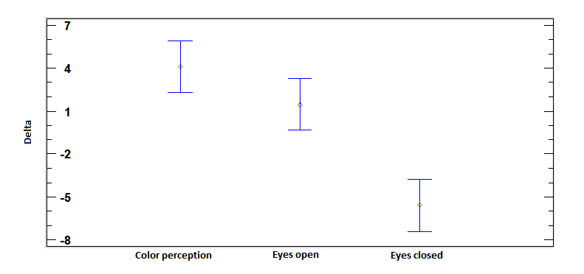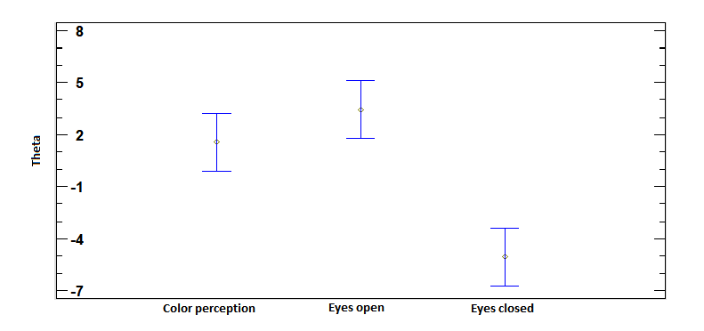

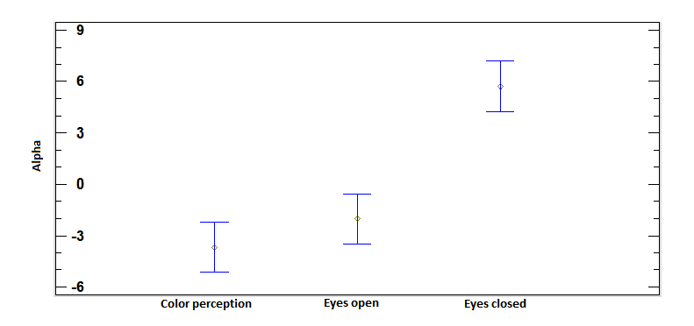

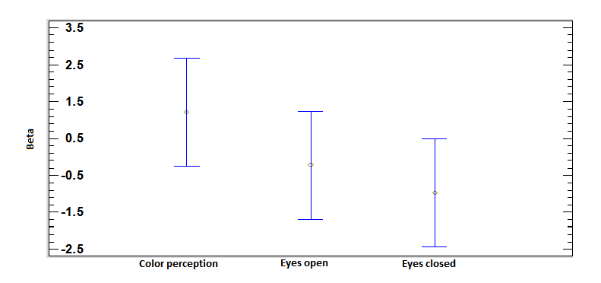

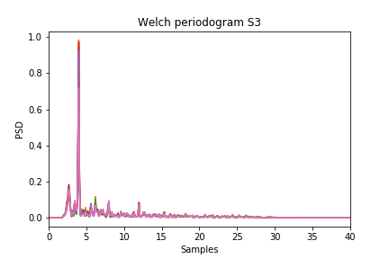

Contrast both

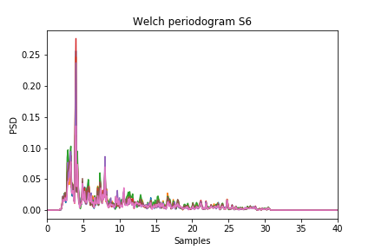

Acuity both

## **Study in patients with neuro-ophthalmological disorders**

## **Classification**

# **Conclusions**

# **Bibliography**

[1] I. Pasley, S. Jobke, A. Julia Gudlin, and B. A. Sabel, “Application of Neural Plasticity for Vision Restoration after Brain Damage,” in *Neuroengineering*, 2008, p. 23.

[2] F. I. R. Owe *et al.*, “Visual impairment following stroke : do stroke patients require vision assessment ?,” no. November 2008, pp. 188–193, 2009.

[3] Stroke Association, “State of the nation,” no. January, 2017.

[4] E. Leung and W. M. Jay, “Stroke and Visual Rehabilitation,” vol. 15, no. 1, pp. 27–36, 2008.

[5] L. Wright *et al.*, “Stroke management: Updated recommendations for treatment along the care continuum,” *Intern. Med. J.*, vol. 42, no. 5, pp. 562–569, 2012.

[6] B. E. Wallace, N. Carolina, A. K. Wagner, and E. P. Wagner, “A History and Review of Quantitative Electroencephalography in Traumatic Brain Injury,” vol. 16, no. 2, pp. 165–190, 2001.

[7] T. K. Pogoda *et al.*, “Multisensory impairment reported by veterans with and without mild traumatic brain injury history,” *J. Rehabil. Res. Dev.*, vol. 49, no. 7, p. 971, 2012.

[8] K. Mckenna, D. M. Cooke, J. Fleming, A. Jefferson, and S. Ogden, “The incidence of visual perceptual impairment in patients with severe traumatic brain injury,” vol. 20, no. May, pp. 507–518, 2006.

[9] M. de Salud, “Carga de enfermedad por enfermedades crónicas no transmisibles y discapacidad en Colombia.,” pp. 38–53.

[10] E. By and T. J. Liesegang, “Neurovisual rehabilitation: recent devel- opments and future directions.,” 2000.

[11] World Health Organization, “Neurological disorders: a public health approach,” *Neurol. Disord. public Heal. challenges.*, pp. 41–176, 2006.

[12] F. R. Carrick, “Eye-Movement Training Results in Changes in qEEG and NIH Stroke Scale in Subjects Suffering from Acute Middle Cerebral Artery Ischemic Stroke: A Randomized Control Trial,” vol. 7, no. January, 2016.

[13] G. E. Legge and S. T. L. Chung, “Low Vision and Plasticity : Implications for Rehabilitation.”

[14] et al. Crosson B, Ford A, McGregor KM, “Functional Imaging and Related Techniques: An Introduction for Rehabilitation Researchers.,” *J Rehabil Res Dev*, vol. 47, no. 2, pp. 1–33, 2010.

[15] F. Lopes da Silva, “EEG and MEG: Relevance to neuroscience,” *Neuron*, vol. 80, no. 5, pp. 1112–1128, 2013.

[16] S. Finnigan and M. J. A. M. Van Putten, “EEG in ischaemic stroke : Quantitative EEG can uniquely inform ( sub- ) acute prognoses and clinical management,” *Clin. Neurophysiol.*, vol. 124, no. 1, pp. 10–19, 2013.

[17] K. E. Thornton, “The Role of the Quantitative EEG in the Diagnosis and Rehabilitation of the Traumatic Brain Injured Patients,” pp. 345–361.

[18] J. Sanchez-lopez *et al.*, “Visually evoked responses from the blind field of hemianopic patients,” *Neuropsychologia*, 2017.

[19] E. Mezer, C. A. Westall, G. Mirabella, T. Wygnanski-Jaffe, R. Yagev, and J. R. Buncic, “Measuring recovery of visual function in children with papilledema using sweep visual evoked potentials,” *J. AAPOS*, vol. 20, no. 3, pp. 252–257, 2016.

[20] C. Hemptinne, J. Liu-Shuang, D. Yuksel, and B. Rossion, “Rapid objective assessment of contrast sensitivity and visual acuity with sweep visual evoked potentials and an extended electrode array,” *Investig. Ophthalmol. Vis. Sci.*, vol. 59, no. 2, pp. 1144–1157, 2018.

[21] W. V. Good, C. Hou, and A. M. Norcia, “Spatial contrast sensitivity vision loss in children with cortical visual impairment,” *Investig. Ophthalmol. Vis. Sci.*, vol. 53, no. 12, pp. 7730–7734, 2012.

[22] F. Almoqbel, S. J. Leat, and E. Irving, “The technique, validity and clinical use of the sweep VEP,” *Ophthalmic Physiol. Opt.*, vol. 28, no. 5, pp. 393–403, 2008.

[23] J. P. Kelly, K. Tarczy-Hornoch, E. Herlihy, and A. H. Weiss, “Occlusion therapy improves phase-alignment of the cortical response in amblyopia,” *Vision Res.*, vol. 114, pp. 142–150, 2015.

[24] H. S. M. Kiiski *et al.*, “Delayed P100-Like Latencies in Multiple Sclerosis: A Preliminary Investigation Using Visual Evoked Spread Spectrum Analysis,” *PLoS One*, vol. 11, no. 1, p. e0146084, 2016.

[25] C. Barber and D. Keating, “Comparison of cathode ray tube and liquid crystal display stimulators for use in multifocal VEP,” pp. 115–122, 2014.

[26] M. Molnár *et al.*, “Spectral and complexity features of the EEG changed by visual input in a case of subcortical stroke compared to healthy controls,” *Clin. Neurophysiol.*, vol. 117, no. 4, pp. 771–780, 2006.

[27] A. A. Brewer and B. Barton, “Visual Field Map Organization in Human Visual Cortex,” *Intech Open Sci.*, vol. 10.5772/51, 2012.

[28] R. F. Dougherty, V. M. Koch, A. A. Brewer, J. Modersitzki, and B. A. Wandell, “Visual field representations and locations of visual areas V1 / 2 / 3 in human visual cortex,” pp. 586–598, 2003.

[29] B. A. Wandell, S. O. Dumoulin, and A. A. Brewer, “Review Visual Field Maps in Human Cortex,” no. 1893, pp. 366–383, 2007.

[30] S. Prasad and S. L. Galetta, *Anatomy and physiology of the afferent visual system*, 1st ed., vol. 102, no. 617. Elsevier B.V., 2011.

[31] S. Stevens, “How to measure distance visual acuity,” *Eye Heal. J.*, p. 2014, 2014.

[32] F. Ejzenbaum, A. Berezovsky, and P. Y. Sacai, “Age norms for monocular grating acuity measured by sweep-VEP in the first three years of age,” vol. 71, no. 3, pp. 7–8, 2008.

[33] B. H. Hospital and B. H. Hospital, “Improving outcome in stroke patients with visual problems,” no. July, pp. 560–565, 2006.

[34] F. Ricci, C. Cedrone, and L. Cerulli, “Review article Standardized measurement of visual acuity,” no. 9100119, pp. 1990–1995, 1998.

[35] Y. Kim, “Cortical sources of Vernier acuity in the human visual system : An EEG-source imaging study,” vol. 17, pp. 1–12, 2017.

[36] S. Ajami, A. Mahnam, and V. Abootalebi, “Development of a practical high frequency brain–computer interface based on steady-state visual evoked potentials using a single channel of EEG,” *Biocybern. Biomed. Eng.*, vol. 38, no. 1, pp. 106–114, 2018.

[37] F. M. Almoqbel, E. L. Irving, and S. J. Leat, “Visual Acuity and Contrast Sensitivity Development in Children : Sweep Visually Evoked Potential and Psychophysics,” vol. 94, no. 8, 2017.

[38] M. Bach, J. P. Maurer, and M. E. Wolf, “Visual evoked potential-based acuity assessment in normal vision, artificially degraded vision, and in patients,” *Br. J. Ophthalmol.*, vol. 92, no. 3, pp. 396–403, 2008.

[39] A. S. Hawkins, J. P. Szlyk, Z. Ardickas, K. R. Alexander, and J. T. Wilensky, “Comparison of contrast sensitivity, visual acuity, and Humphrey visual field testing in patients with glaucoma,” *J Glaucoma*, vol. 12, pp. 134–138, 2003.

[40] D. G. Pelli and P. Bex, “Measuring contrast sensitivity,” pp. 10–14, 2014.

[41] L. J. Balcer *et al.*, “Contrast letter acuity as a visual component for the Multiple Sclerosis Functional Composite,” vol. 000, pp. 1367–1374, 2003.

[42] K. Boyd, “Visual Field Test,” 2019. [Online]. Available: https://www.aao.org/eye-health/tips-prevention/visual-field-testing.

[43] J. G. Romano, P. Schulz, S. Kenkel, and D. P. Todd, “Visual field changes after a rehabilitation intervention: Vision restoration therapy,” vol. 273, pp. 70–74, 2008.

[44] E. Kasten, U. Bunzenthal, and B. A. Sabel, “Visual field recovery after vision restoration therapy ( VRT ) is independent of eye movements : An eye tracker study,” vol. 175, pp. 18–26, 2006.

[45] I. Mueller, H. Mast, and B. A. Sabel, “Recovery of visual field defects : A large clinical observational study using vision restoration therapy,” vol. 25, pp. 563–572, 2007.

[46] A. Borst and M. Egelhaaf, “Principles of visual motion detection,” pp. 297–306, 1989.

[47] T. H. Donner, M. Siegel, R. Oostenveld, P. Fries, M. Bauer, and A. K. Engel, “Population Activity in the Human Dorsal Pathway Predicts the Accuracy of Visual Motion Detection,” *J Neurophysiol 98*, vol. 98, pp. 345–359, 2007.

[48] V. Walsh, A. Ellison, L. Battelli, and A. Cowey, “Task-specific impairments and enhancements induced by magnetic stimulation of human visual area V5,” vol. 5, no. November 1997, 1998.

[49] L. M. Hamm, J. Black, S. Dai, and B. Thompson, “Global processing in amblyopia: a review,” vol. 5, no. June, pp. 1–21, 2014.

[50] F. Rocchi and B. S. Webb, “Criterion-free measurement of motion transparency perception at different speeds,” vol. 18, pp. 1–12, 2018.

[51] J. E. Raymond, “Attentional modulation of visual motion perception,” vol. 4, no. 2, pp. 42–50, 2000.

[52] S. O. Murray, D. Kersten, B. A. Olshausen, P. Schrater, and D. L. Woods, “Shape perception reduces activity in human primary visual cortex,” *PNAS*, vol. 99, p. 23, 2002.

[53] T. W. James, J. Culham, G. K. Humphrey, A. D. Milner, and M. A. Goodale, “Ventral occipital lesions impair object recognition but not object-directed grasping : an fMRI study,” 2003.

[54] I. Kurki and J. Saarinen, “Investigating shape perception by classification images,” *J. Vis.*, vol. 14, pp. 1–19, 2014.

[55] B. J. B. Nicole M. Gage, *Fundamentals of Cognitive Neuroscience (Second Edition)*. 2018.

[56] H. O. Karnath, J. Rüter, A. Mandler, and M. Himmelbach, “The anatomy of object recognition - Visual form agnosia caused by medial occipitotemporal stroke,” *J. Neurosci.*, vol. 29, no. 18, pp. 5854–5862, 2009.

[57] G. W. A. James C. Grotta, *Stroke. Pathophysiology, Diagnosis, and Management*. 2016.

[58] P. Kok and F. P. De Lange, “Shape perception simultaneously up- and downregulates neural activity in the primary visual cortex,” *Curr. Biol.*, vol. 24, no. 13, pp. 1531–1535, 2014.

[59] J. D. Yeatman, A. M. Rauschecker, and B. A. Wandell, “Brain & Language Anatomy of the visual word form area : Adjacent cortical circuits and long-range white matter connections,” *Brain Lang.*, vol. 125, no. 2, pp. 146–155, 2013.

[60] L. Cohen, S. Dehaene, F. Vinckier, A. Jobert, and A. Montavont, “Reading normal and degraded words : Contribution of the dorsal and ventral visual pathways,” vol. 40, pp. 353–366, 2008.

[61] M. Vigneau, G. Jobard, B. Mazoyer, and N. Tzourio-mazoyer, “Word and non-word reading : What role for the Visual Word Form Area ?,” vol. 27, pp. 694–705, 2005.

[62] F. Chochon *et al.*, “Language-specific tuning of visual cortex ? Functional properties of the Visual Word Form Area,” *Brain*, pp. 1054–1069, 2002.

[63] P. E. Turkeltaub *et al.*, “Alexia due to ischemic stroke of the visual word form area,” *Neurocase*, vol. 20, no. 2, pp. 230–235, 2014.

[64] C. Terms, “Color Vision,” vol. 41, no. 3, 2000.

[65] K. Seymour, C. W. G. Clifford, and N. K. Logothetis, “The Coding of Color , Motion , and Their Conjunction in the Human Visual Cortex,” *Curr. Biol.*, vol. 19, no. 3, pp. 177–183, 2009.

[66] S. Zeki and A. Bartels, “The clinical and functional measurement of cortical ( in ) activity in the visual brain , with special reference to the two subdivisions ( V4 and V4 a ) of the human colour centre,” 1999.

[67] S. E. Bouvier and S. A. Engel, “Behavioral Deficits and Cortical Damage Loci in Cerebral Achromatopsia,” *Cereb. Cortex*, no. February, pp. 183–191, 2006.

[68] M. A. Crognale, C. S. Duncan, D. J. Peterson, and M. E. Berryhill, “The locus of color sensation : Cortical color loss and the chromatic visual evoked potential,” *Vision*, vol. 13, pp. 1–11, 2013.

[69] D. J. Mckeefry and S. Zeki, “The position and topography of the human colour centre as revealed by functional magnetic resonance imaging,” pp. 2229–2242, 1997.

[70] and N. K. Mona Spiridon, Bruce Fischl, “Location and Spatial Profile of Category-Specific Regions in Human Extrastriate Cortex,” vol. 27, no. 1, pp. 77–89, 2012.

[71] S. Km, A. Midelfart, L. Thomassen, A. Melms, H. Wilhelm, and H. Jm, “Visual impairment in stroke patients – a review,” vol. 127, pp. 52–56, 2013.

[72] G. Kerkhoff, “Restorative and compensatory therapy approaches in cerebral blindness – a review,” vol. 15, pp. 255–271, 1999.

[73] R. J. Nudo, “Recovery after brain injury: mechanisms and principles,” *Front. Hum. Neurosci.*, vol. 7, no. December, pp. 1–14, 2013.

[74] A. Pascual-leone, A. Amedi, F. Fregni, and L. B. Merabet, “The Plastic Human Brain Cortex,” 2005.

[75] A. T. Toosy, “Valuable Insights Into Visual Neuroplasticity After Optic Neuritis,” pp. 1–2, 2018.

[76] I. Mueller *et al.*, “Vision restoration therapy after brain damage : Subjective improvements of activities of daily life and their relationship to visual field enlargements to visual field enlargements,” vol. 5167, no. January 2016, 2009.

[77] G. K. V, D. Strasse, and D.- München, “Neurovisual rehabilitation : recent developments and future directions,” pp. 691–706, 2000.

[78] J. H. Pula and C. A. Yuen, “Eyes and stroke: The visual aspects of cerebrovascular disease,” *Stroke Vasc. Neurol.*, vol. 2, no. 4, pp. 210–220, 2017.

[79] L. F. Nicolas-Alonso and J. Gomez-Gil, “Brain computer interfaces, a review,” *Sensors*, vol. 12, no. 2, pp. 1211–1279, 2012.

[80] S. S. and J. A. Chambers, *EEG Signal Processing*. 2007.

[81] X. Lei *et al.*, “Identification of EEG features in Stroke Patients based on Common Spatial Pattern and Sparse Representation Classification,” pp. 114–117, 2017.

[82] Encyclopedia, *Medical Devices and Human Engineering*, vol. 5. 2006.

[83] J. Leon-carrion, J. F. Martin-rodriguez, J. Damas-lopez, J. Manuel, and M. R. Dominguez-morales, “Clinical Neurophysiology Delta – alpha ratio correlates with level of recovery after neurorehabilitation in patients with acquired brain injury,” *Clin. Neurophysiol.*, vol. 120, no. 6, pp. 1039–1045, 2009.

[84] A. Mora-Cortes, K. R. Ridderinkhof, and M. X. Cohen, “Evaluating the feasibility of the steady-state visual evoked potential (SSVEP) to study temporal attention,” *Psychophysiology*, no. June, 2017.

[85] X. Gao, D. Xu, M. Cheng, and S. Gao, “A BCI-based environmental controller for the motion-disabled,” *IEEE Trans. Neural Syst. Rehabil. Eng.*, vol. 11, no. 2, pp. 137–140, 2003.

[86] A. M. Norcia, L. G. G. Appelbaum, J. M. J. M. Ales, B. R. B. R. Cottereau, and B. Rossion, “The steady-state visual evoked potential in vision research: a review,” *J. Vis.*, vol. 15, no. 6, p. 4, 2015.

[87] Y. Wang, X. Gao, B. Hong, C. Jia, and S. Gao, “Brain-Computer Interfaces Based on Visual Evoked Potentials,” *Ieee Eng. Med. Biol. Mag.*, vol. 27, no. 5, pp. 64–71, 2008.

[88] J. A. G. Heckenlively, *Principles and practice of clinical electrophysiology of vision.* 2006.

[89] S. J. Leat, L. M. Head, and E. L. Irving, “Effects of sweep VEP parameters on visual acuity and contrast thresholds in children and adults,” *Graefes Arch Clin Exp Ophthalmol*, pp. 613–623, 2011.

[90] N. V. T. Shanbao Tong, *Quantative EEG Analysis Methods and Clinical Applications*. 2009.

[91] S. Stathopoulou, “EEG Changes in Traumatic Brain Injured Patients After Cognitive Rehabilitation,” *J. Neurother.*, vol. 8, no. 2.

[92] M. Pharmacology, P. Health, and L. Angeles, “Early and persistent impaired percent alpha variability on continuous electroencephalography monitoring as predictive of poor outcome after traumatic brain injury,” *J Neurosurg*, vol. 97, pp. 84–92, 2002.

[93] Y. A. L. Pijnenburg, Y. Vd Made, A. M. Van Cappellen Van Walsum, D. L. Knol, P. Scheltens, and C. J. Stam, “EEG synchronization likelihood in mild cognitive impairment and Alzheimer’s disease during a working memory task,” *Clin. Neurophysiol.*, vol. 115, no. 6, pp. 1332–1339, 2004.

[94] C. J. Stam and B. W. Van Dijk, “Synchronization likelihood: An unbiased measure of generalized synchronization in multivariate data sets,” *Phys. D Nonlinear Phenom.*, vol. 163, no. 3–4, pp. 236–251, 2002.

[95] J. T. Lizier, M. Prokopenko, and A. Y. Zomaya, “Local measures of information storage in complex distributed computation,” *Inf. Sci. (Ny).*, vol. 208, pp. 39–54, 2012.

[96] “OpenBCI shop,” *https://shop.openbci.com/products/cyton-biosensing-board-8-channel?variant=38958638542*. .

[97] W. H. Ridder, I. I. I. Anna, and T. Floresca, “Reliability of acuities determined with the sweep visual evoked potential ( sVEP ),” *Doc Ophthalmol*, pp. 99–107, 2012.

[98] J. M. L. De Faria, O. Katsumi, M. Arai, and T. Hirose, “Objective measurement of contrast sensitivity function using contrast sweep visual evoked responses,” *Br. J. Ophthalmol.*, pp. 168–173, 1998.

[99] A. M. Skoczenski and A. M. Norcia, “Development of VEP Vernier Acuity and Grating Acuity in Human Infants,” *Invest. Ophthalmol. Vis. Sci.*, 2018.

[100] C. Hou, W. V Good, and A. M. Norcia, “Detection of Amblyopia Using Sweep VEP Vernier and Grating Acuity,” *Investig. Ophthalmol. Vis. Sci.*, 2018.

[101] A. L. Ely *et al.*, “Degradation of Swept-Parameter VEP Responses by Neutral Density Filters in Amblyopic and Normal Subjects,” *Investig. opthalmology Vis. Sci.*, 2018.

[102] H. Ja, “A comparison of the performance of three visual evoked potential-based methods to estimate visual acuity,” *Doc Ophthalmol*, pp. 45–56, 2013.

[103] E. M. Santos, E. K. Gnang, and E. Kowler, “Anticipatory smooth eye movements with random-dot kinematograms,” vol. 12, pp. 1–20, 2012.

# **Supplementary material**

Basic information for healthy participant:

|  |  |  |  |
| --- | --- | --- | --- |
| **Group 1** | | | |
| **Code** | **Dominat eye** | **Age** | **Gender** |
| S1 | Left | 25 | F |
| S2 | Right | 30 | F |
| S3 | Left | 19 | F |
| S4 | Left | 24 | M |
| S5 | Right | 43 | F |
| S6 | Right | 24 | M |
| S7 | Right | 25 | M |
| S8 | Right | 25 | F |
| S9 | Right | 35 | M |
| S10 | Left | 20 | F |
| S11 | Right | 22 | M |
| S12 | Left | 24 | F |
| S13 | Left | 24 | M |
| S14 | Left | 19 | M |
| S15 | Left | 25 | F |
| S16 | Right | 28 | M |
| S17 | Right | 29 | M |
| S18 | Right | 39 | M |
| S19 | Right | 22 | F |
| S20 | Left | 27 | M |
| S21 | Left | 35 | M |
| S22 | Right | 25 | M |
| S23 | Right | 22 | M |
| S24 | Right | 22 | F |

|  |  |  |  |
| --- | --- | --- | --- |
| **Group 2** | | | |
| **Code** | **Dominat eye** | **Age** | **Gender** |
| 2S1 | Right | 23 | F |
| 2S2 | Right | 23 | M |
| 2S3 | Right | 23 | M |
| 2S4 | Left | 24 | M |
| 2S5 | Right | 29 | M |
| 2S6 | Right | 53 | F |
| 2S7 | Right | 24 | M |
| 2S8 | Left | 22 | M |
| 2S9 | Left | 25 | M |
| 2S10 | Left | 25 | F |
| 2S11 | Left | 25 | F |
| 2S12 | Right | 35 | M |
| 2S13 | Right | 22 | F |

<http://wiki.bethanycrane.com/introducingtheeye>

<http://fourier.eng.hmc.edu/e180/lectures/v1/node7.html>

<https://slideplayer.com/slide/9831944/>

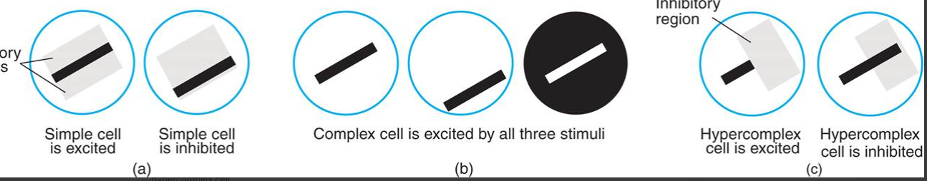

<https://mlsauce.wordpress.com/2018/06/12/simple-and-complex-cells-in-the-visual-cortex-inspiring-the-sauce/>

<https://www.researchgate.net/publication/277310946_Dynamic_Field_Theory_of_Visuospatial_Cognition/figures?lo=1>

___________________________ _____________________________

Tutor: John Fredy Ochoa Co-Tutor: Juan Camilo Suarez

C.C. 71279364 C.C. 8163158

_____________________________

Estudiante: Daniela Ortega Rosero

C.C. 1017213273